Award Application - Word Template
APPLICATION: Deadline 4th December 2023
Contents
Introduction 2
Evidence should be presented in the following format: 3
Overview and Context (max 500 words) 4
Blue Zone 5
Leadership (max 750 words) 5
Culture (max 750 words) 5
Governance (max 750 words) 5
Teal Zone 6
Operational Agility (max 750 words) 6
Support or Change Agility (max 750 words) 6
Purple Zone 7
Customers (max 750 words) 7
People (max 750 words) 7
Ecosystem (max 750 words) 7
Grey Zone 8
Strategy (max 750 words) 8
Required fields 8
Application Milestones 9

Introduction
Thank you for entering these 2024 Agile Business Awards, we’re excited to have you as part of this celebration of business agility in forward-thinking organisations. Please choose one of the following four categories for your entry: Agility in Finance, Procurement and Contracts; Agility in HR; Agility in Marketing; Overall Business Agility.
- Reminder: your application will be scored by at least 3 independent reviewers who are experts in the category for which you have applied
- You will receive written feedback on your application; please note this will not be until after the review process is completed. Feedback will consist of comments from the reviewers, based on how they understood your application. We will NOT publish NOR discuss the scores, with anyone beyond the reviewer panel
- We will be basing our score solely on the information and evidence you provide, rather than that published elsewhere
- The sections of our application are based on the Framework for Business Agility
- Successful applicants will be invited to speak at the Agile Business Conference 17th & 18th April 2024.
- You can apply as an enterprise, an organisation, a business unit, a department, or any part of an organisation. Ensure that all evidence relates to the part of the organisation for which you are applying. So, if you are applying for the French Business unit of an international business, all evidence will relate to the French business unit, and not to the German business unit
- We will not accept applications from consultancy organisations (but consultancy organisations are invited to help their clients with an application)

All information supplied (except for overview and context) should be written in the format of ‘evidence stories’. We expect several evidence stories per category, which should be presented in a concise format (see below example).
Please note: there is a maximum word count per section

Evidence should be presented in the following format:
- Situation (S)
- What did you do and how? (A)ction
- Results achieved (R)
- Lessons learned (L)
Based on any one Situation, there can be several Actions, Results and Lessons learned.

So, for example in the People section:
We had a situation (S), where we were receiving an unacceptably high number of customer complaints, which were not being dealt with fast enough – leading to further complaints.
A customer survey and feedback along the lines of “the right hand does not seem to know what the left hand is doing” and “I kept getting passed from one department to another but no one would take responsibility” helped us to conclude that most people were still working in siloed departments and not collaborating to serve our customers better.

We looked at the 7th principle of the agile people manifesto,
“Agile People harness the power of boundary spanning to facilitate proactive collaboration across organisational barriers”

and in (A) cross-functional workshops we explored how we could provide better customer service. As a result (R + L), we now understand each other much better and have greater insight into each other’s functions and challenges, and agreed that from a customer's point of view it did not matter which department was ‘responsible’.

(A) We tested the hypotheses from the workshops in a series of experiments, including:
- Whoever first picks up the enquiry takes ownership and collaborates with other departments where necessary to resolve
- Cross department groups meet weekly to discuss issues from that week and suggest process improvement – often followed by social events
- Cross-functional workshops to identify further improvements every quarter – with social events added
(R) Subsequent customer satisfaction surveys indicated significant improvement, with the number of complaints, and complaints waiting to be resolved, going down. We conclude our experiments to have been a success and (L) will continue to monitor and improve.
For every evidence story, we would like to see some supportive evidence. For example, for the story above:
- Screenshot of workshop output/collaboration e.g., Miro or Mural board or photos of flipcharts
- Communications around changes to practices
- Calendar entries for future series of workshops
- Job titles or functions of those involved in the workshops
- Results or NPS (net promoter score) scores from customer satisfaction surveys (before and after)
- The meeting calendar for an upcoming joint meeting, and the graph showing customer satisfaction to have gone up). 10 pictures maximum

- This document is here to support your application. We advise you to work offline and to save your progress before completing the online form.
- For application support and questions please contact info@agileconference.org

Overview and Context (max 500 words)
NOTE: This section is for reference only; information supplied here will NOT be scored but will simply provide context for reviewers.
Please include:
- Which part of your organisation this application is based on - full organisation, a division or department, a business unit etc.
- Why you are applying for this category
- The organisational context for this application
- Whether this is the standard way of working in this organisation, or an improvement
- Any general information, so the application can be understood in its context (national/international, market etc.)
- For an explanation of the categories, please refer to the webpage.

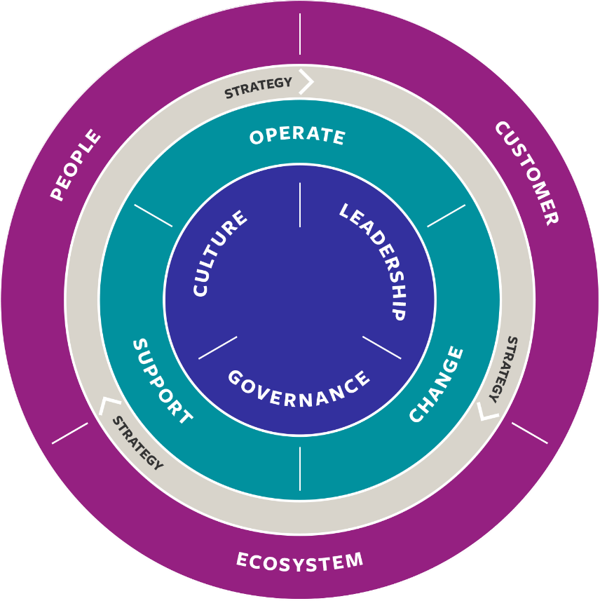

Blue Zone
In successful organisations agility will be embedded in the organisation’s culture, leadership and governance - the core of the Framework for Business Agility.

Leadership (max 750 words)
Leadership is found throughout the organisation. Constantly improving the organisation to deliver outcomes, value and impact requires supportive, thoughtful, focused leadership.
- Please write your answer in the form of evidence stories up to a maximum of 6.
- Please provide some evidence / pictures / recommendations etc. to support your evidence stories (evidence can be uploaded on the online application form)
Please consider:
- How you have defined and built the leadership competencies needed in your agile organisation?
- How you have supported and maintained the leadership approach?
- What you have learned, what have you achieved, what innovation have you applied in your organisation?

Culture (max 750 words)
“Culture eats strategy for breakfast” highlights Peter Drucker. In many organisations, developing a “growth” mindset and building psychological safety, so that it is OK to fail within boundaries, is not something that comes easily and naturally. However, in an agile organisation, you need to feel safe to experiment and learn. Hence, an agile culture is part of the core of business agility.
- Please write your answer in the form of evidence stories up to a maximum of 6.
- Please provide some evidence/pictures/recommendations etc. to support your evidence stories (evidence can be uploaded on the online application form)
Please consider:
- How you have defined and built the culture needed in your agile organisation?
- How you have supported and maintained an agile culture?
- What you have learned, what have you achieved, what innovation have you applied in your organisation?

Governance (max 750 words)
Agility can be lost in organisations when the wrong people make the wrong choices, taking too much time.
- Please write your answer in the form of evidence stories up to a maximum of 6.
- Please provide some evidence / pictures / recommendations etc. to support your evidence stories (evidence can be uploaded on the online application form)
Please consider:
- How you have defined and built the governance needed in your agile organisation
- How you have supported and maintained the agile governance approach
- What you have learned, what you have achieved, what innovation you have applied in your organisation

Teal Zone
This indicates how, directly or indirectly, value is created to provide outcomes and impact.
Please write evidence for operational agility, and for either change or support.

Operational Agility (max 750 words)
Describing how the organisation directly provides value to its customers, its ecosystem
- Please write your answer in the form of evidence stories up to a maximum of 6.
- Please provide some evidence / pictures / recommendations etc. to support your evidence stories (evidence can be uploaded on the online application form)
Examples you may consider:
- How you have defined and created the direct value production
- How you have maintained and improved value delivery
- What you have learned, what you have achieved, what innovation you have applied in your organisation

Support or Change Agility (max 750 words)
Please indicate whether you have chosen to include supporting agility (such as HR, Finance, Procurement, IT, etc.), or change agility (such as project management, change management, programme management etc) in your application. Pick either one to write your evidence.
- Please write your answer in the form of evidence stories up to a maximum of 6.
- Please provide some evidence / pictures / recommendations etc. to support your evidence stories (evidence can be uploaded on the online application form)
Examples you may consider:
- How you have defined and created the delivery?
- How you have maintained and improved the delivery?
- What you have learned, what have you achieved, what innovation have you applied in your organisation?

Purple Zone
An agile organisation is always sustainably delivering added value to their customers, their ecosystem and their people – their staff. This is the trigger to constantly improve, adjust, and learn.

Customers (max 750 words)
In the agile world, we are always focused on sustainably, consistently and increasingly providing (added) value for customers. It is in the values and the principles of all agile manifestos.
- Please write your answer in the form of evidence stories up to a maximum of 6.
- Please provide some evidence / pictures / recommendations etc. To support your evidence stories (evidence can be uploaded on the online application form)
Examples you may consider:
- What value you wanted to create for your customers?
- What value you achieved for your customers?
- How you measure achieving success?
- Where there are innovations in process or technology you have used to increase success?
- How did you learn, with your customer, to provide even more value?

People (max 750 words)
People, your staff, are the core of your success. Purpose Driven People, in direct contact with customers, are a key enabler to an organisation’s success.
- Please write your answer in the form of evidence stories up to a maximum of 6.
- Please provide some evidence / pictures / recommendations etc. To support your evidence stories (evidence can be uploaded on the online application form)
Examples you may consider:
- What value you wanted to create for your people?
- What value you have achieved for your people?
- How did you measure achieving success?
- Where there are innovations in process or technology you have used to increase success?
- How did you learn, with your people, to provide even more value?

Ecosystem (max 750 words)
Ecosystem is the external environment. It might refer to regulators, the supply chain, the social environment, and/or the ecological environment you are in. i.e. the impact you make on society at large.
Please, when describing your impact, ensure the reviewers know what aspects of your ecosystem you are referring to. There is no need to write about all, we would expect at least 2 different parts (for example impact on supply chain and impact on the usage of base materials or so).
- Please write your answer in the form of evidence stories up to a maximum of 6.
- Please provide some evidence / pictures / recommendations etc. To support your evidence stories (evidence can be uploaded on the online application form)
Examples you may consider:
- What value you wanted to create for your ecosystem?
- What value you have achieved for your ecosystem?
- How did you measure achieving success?
- What innovations in process or technology have been used to increase success?
- How did you learn, with your ecosystem, to provide even more value?

Grey Zone

Strategy (max 750 words)
In a VUCA (Volatile, Uncertain, Complex, Ambiguous) world, an organisation needs to be able to flex its strategy and implementation to keep up with its environment, whilst maintaining quality.
- Please write your answer in the form of evidence stories up to a maximum of 6.
- Please provide some evidence / pictures / recommendations etc. To support your evidence stories (evidence can be uploaded on the online application form)
Examples you may consider:
- How you have defined your strategy, using knowledge, data and experience
- How did you adapt your strategy?
- How did you learn, to provide even more strategic value?

Required fields
Application Contact Details: (This information will be used for communications about the Awards)
Approval & Consent to Share (these are required fields on the online form)
I can confirm that either myself or a colleague would be able to share and present a version of this case study/story publicly as a 20 min talk on 17th & 18th April 2024.
The information in my application can be shared with reviewers for the Awards by the Agile Business Consortium.

Application Milestones
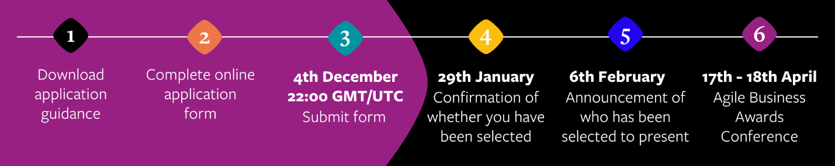
Step 1 – Register your interest or nominate an organisation for 2024 Applications
Step 2 – Download the application guidance
Step 3 – Start collecting and drafting information and evidence for the application, using this Application Guidance document
Step 4 – Complete the online form by copying in your prepared application, and submit by 4th December 22:00 GMT/UTC
29th January – Organisations will be informed whether they have been selected for awards and are invited to speak at the Awards Conference
6th February – Public announcement of selected organisations for each category i.e., those that will be invited to present at the Awards Conference
17-18th April – Agile Business Awards Conference

