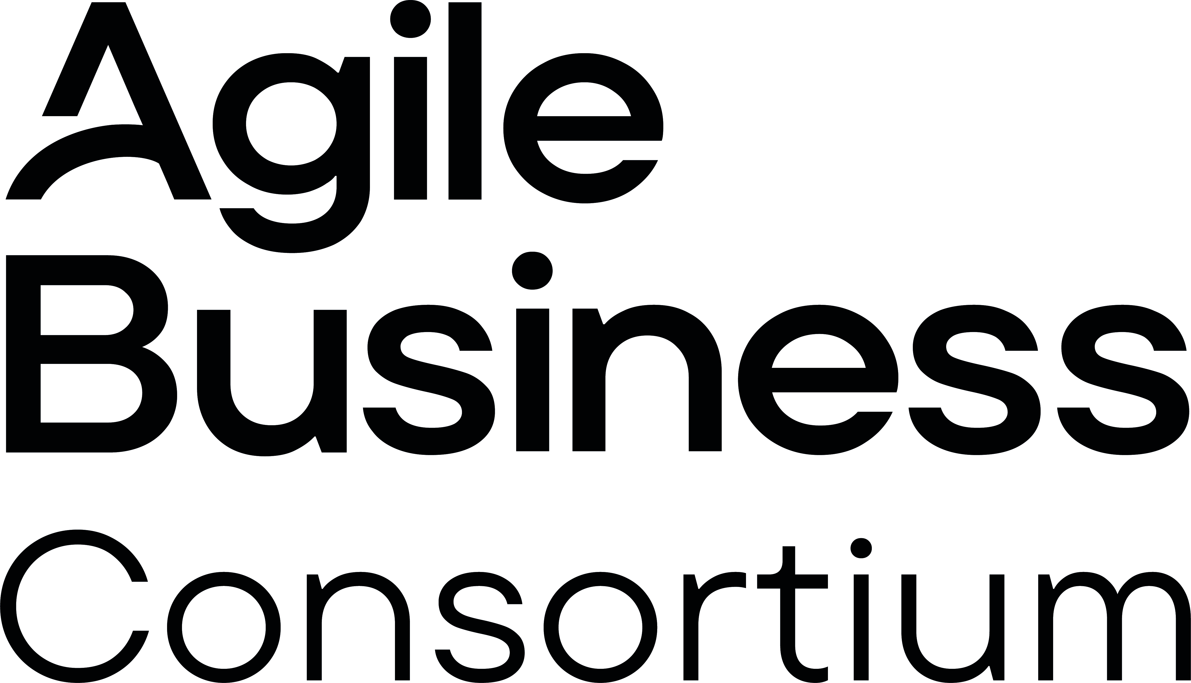
Terms of Reference Template
<< Project Name >>
<< Author >>

Purpose of this document
- To state the business drivers for and objectives of the project
- To describe in outline the scope of the project
- To state how the proposed project contributes to previously stated strategic business objectives, where applicable
- To describe any assumptions, dependencies and constraints already known
- To identify resources required for the Feasibility phase
- To justify and secure funding for a feasibility investigation
Note: The primary purpose of this document is to justify the work required to determine whether the project is likely to be feasible from a technical and business perspective. All of the above should only be described at very high level. Expect only a sentence, a short paragraph or a short list of bullets under each heading.

 | Project Role | Name | Signature & Date
Produced by:
Approved by: | Business Sponsor

Revision History
Name | Ver | Reason for change | Status | Date

Table of Contents
Purpose of this document 1
Table of Contents 2
Business Driver 3
Objectives 3
Scope 3
Project Constraints 3
Benefits 3
Assumptions and Dependencies 3
Project Risks 3
Resources and Facilities Required 4
Timescale and Budget for next steps 4
Stakeholders 4

Business Driver
State the reason for this proposal for a project in the context of strategic or tactical business objectives. A short paragraph should suffice

Objectives
State the key objectives of the proposed project. These should be clearly related to the business driver and be described in terms of business problem or opportunity (not in terms of possible solutions). A short bulleted list should suffice.

Scope
Present an initial view of the project scope sufficient to provide a focus for investigation in the Feasibility phase. Consider including what MUST be in scope, would IDEALLY be in scope and what is ruled OUT of scope. For clarity, consider inserting a simple context diagram to illustrate with people, processes and major information flows related to the likely system solution.

Project Constraints
State any HIGH LEVEL technical and/or business constraints that are already known about. Ensure that regulatory and legal constraints are identified (e.g. must comply with current Financial Services Authority guidance, must deliver in time for next year end accounting process). A short bulleted list should suffice.

Benefits
State at a high level the nature and magnitude of the anticipated benefits that would be enabled if the project were to go ahead. Consider both quantitative and qualitative benefits. State quantitative benefits in broad range that reflects a wide confidence estimate (e.g. increase revenues by £500,000 - £1m per annum, increase productivity by 3-5%). A short bulleted list should suffice.

Assumptions and Dependencies
State any HIGH LEVEL technical and/or business assumptions or dependencies already known that must be considered moving forwards (e.g. depends on project x delivering y first, assumes new business growth trend is sustained). A short bulleted list should suffice.

Project Risks
State any HIGH LEVEL risks associated with this project that are already known. There is no need for formal Risk Analysis at this stage. It is likely that the risks identified here will be related to the Constraints, Assumptions and Dependencies identified above (e.g. there is a significant risk of failure if we cannot train or otherwise acquire suitably skilled development staff). Ensure that risk associated with business change and business participation in the project is as actively considered as risk associated with the building more tangible aspects of the solution. A short bulleted list should suffice.

Resources and Facilities Required
Identify any resources required for Feasibility and, if appropriate, Foundations phases.

Timescale and Budget for next steps
Provide credible estimates of timescale and cost for the Feasibility and, where appropriate, Foundations phases. Remember that the work carried out in Feasibility should be just enough to determine whether the project is likely to be feasible so think in terms of days and weeks for this. Foundations work may be more extensive but should still only be a high level assessment estimated measured in weeks rather than months

Stakeholders
List the key players who will need to be involved in the Feasibility phase and, where already understood, involved in the Foundations and later phases of the project should it be deemed feasible.

